|  |
| --- |
| SHARP |
| Installation Guide |
| Windows Server 2008 R2 Standard – 64bit |

|  |
| --- |
| grvaradharaj  12/26/2011 |

# Accounting plus Software Installation

***Note:***

You should be “**Administrator**” of the system to install Accounting plus Software.

* 1. Double Click “**Setup.exe**”

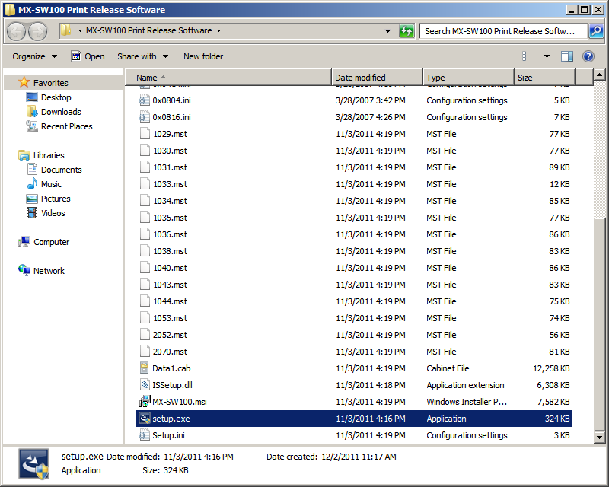

Figure 1: setup

* 1. Select language and click “**OK**”

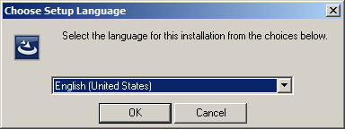

Figure 2: Accounting plus Software Language selection

* 1. Click “**Next >**”

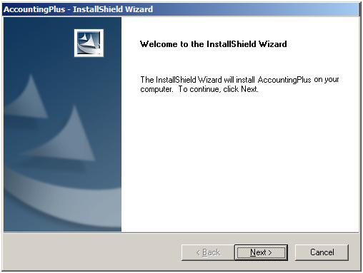

Figure 3: Welcome Wizard

* 1. Select “**I accept the terms of license agreement**”
  2. Click “**Next >**”

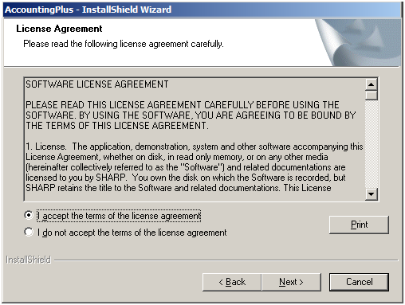

Figure 4: License agreement

* 1. Enter “**User Name**”
  2. Enter “**Company Name**”
  3. Click “**Next >**”

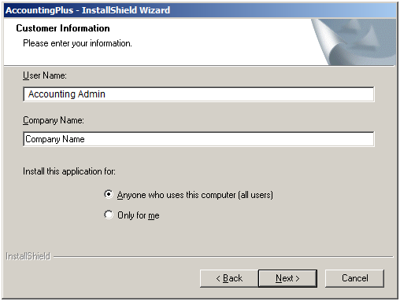

Figure 5: Customer Information

* 1. Select desired destination folder by clicking “**Browse…**” or leave default destination folder
  2. Click “**Next >**”

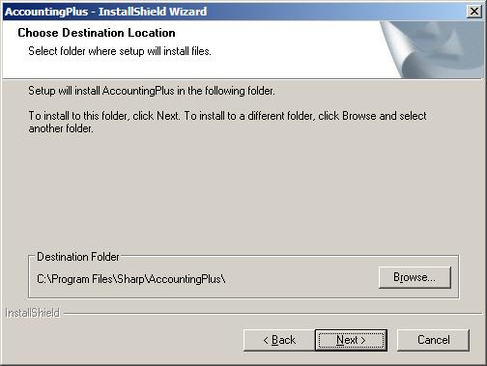

Figure 6: Destination Folder

* 1. Click “**Browse…**”

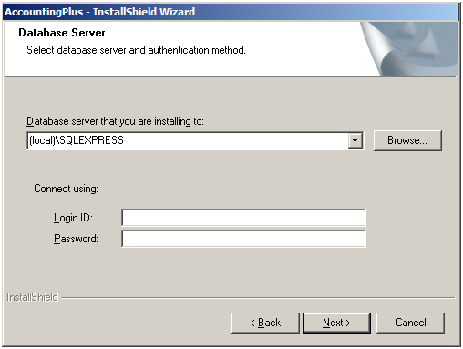

Figure 7: Database Server

* 1. Clicking on “**Browse…**” will launch “**Database Server**” window. This window will list all the live database instances in the network
  2. Select the correct Accounting plus Software instance and host from the list
  3. Click “**OK**”

## 

Figure 8: Database instances

* 1. Enter “**sa**” in “**Login ID**” text field
  2. Enter password [same as of that is provided during SQL installation] in “**Password**” text field
  3. Click “**Next >**”

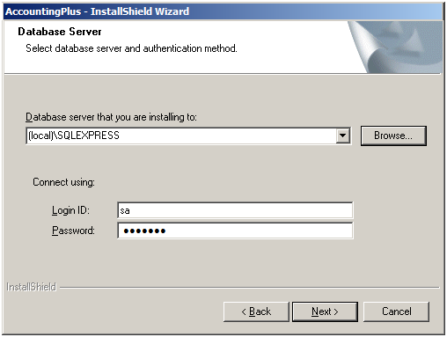

***Same password as of that is provided during SQL installation***

Figure 9: SQL Credentials

* 1. Click “**Install**”

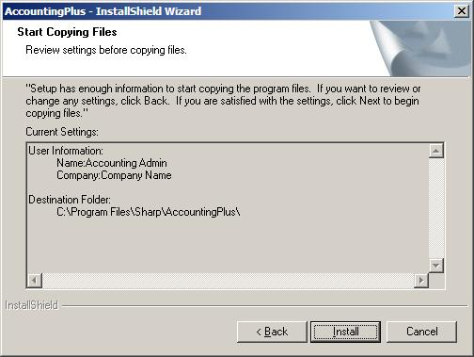

Figure 10: Start Copying Files

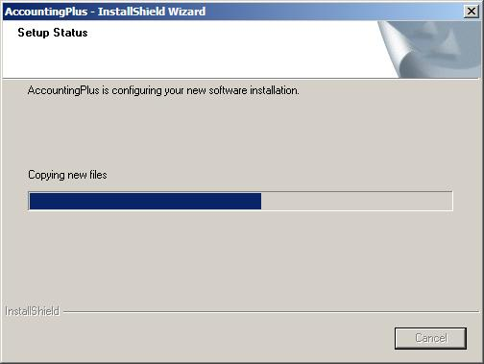

Figure 11: Copying Files

* 1. Click “**Finish**”

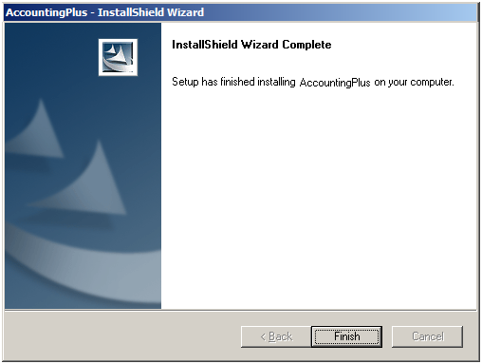

Figure 12: Finish Installation

# Configuring custom port [other than 8090] of Accounting plus Software

* 1. Click start and type “**services.msc**”.
  2. Click “**services.msc**”.

**Click services.msc**

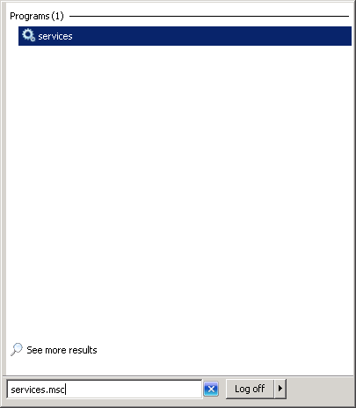

Figure 17: Services.msc

* 1. Locate “**PrintJobListnerService**”
  2. Right click and select “**Stop**”

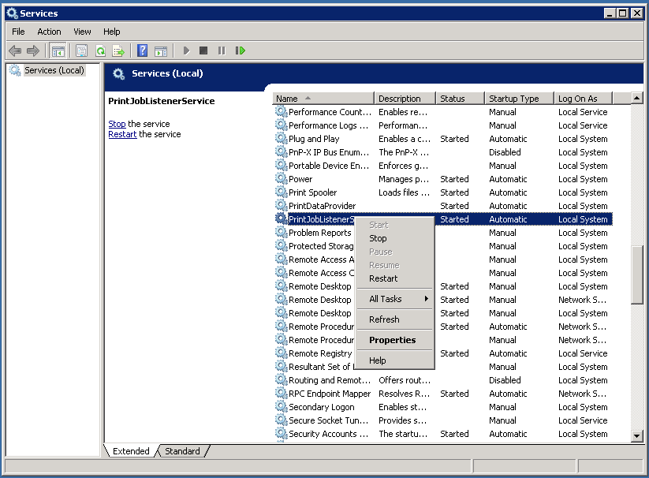

Figure 18: Services

* 1. Navigate to installed location Accounting plus Software

By default Accounting plus Software will be installed in following locations:

For 32 Bit “C:\Program Files\Sharp\MX-SW100”

For 64 Bit “C:\Program Files(x86)\Sharp\MX-SW100”

* 1. Locate “PrintJobListener.exe.config”

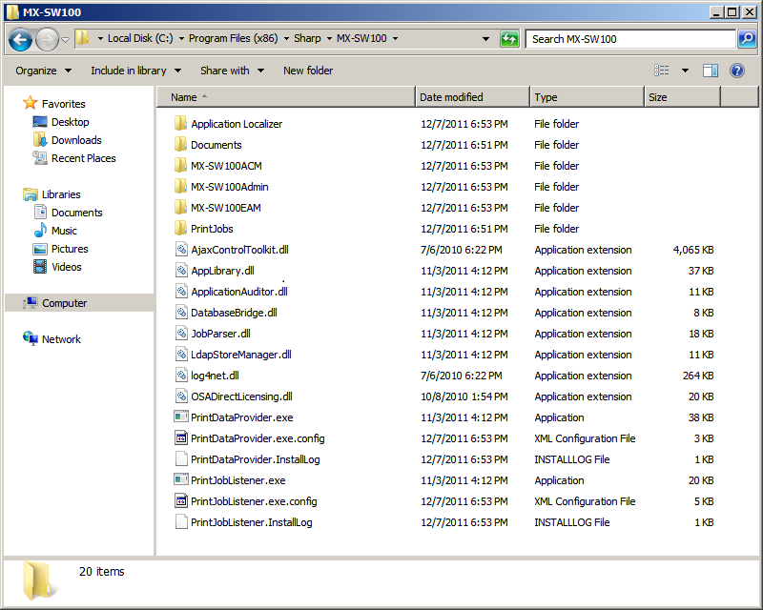

Figure 19: Accounting Plus Software Installed location

* 1. Open “**PrintJobListener.exe.config**” file in notepad.

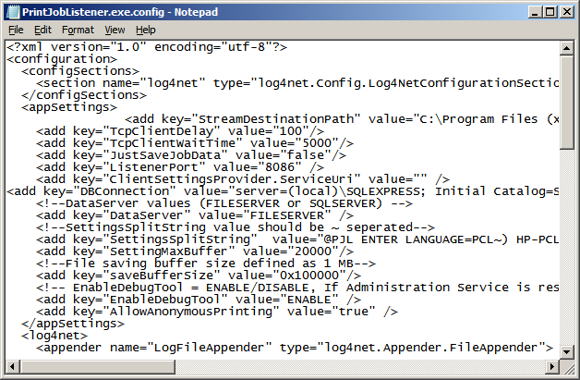

Figure 20: PrintJobListnerService.config

* 1. Locate line with **“<add key="ListenerPort" value="8090" />**”
  2. Change “**8090**” to the desired unused port
  3. Save “**PrintJobListener.exe.config**”

***Note:***

Please refer [***http://www.iana.org/assignments/port-numbers***](http://www.iana.org/assignments/port-numbers) for port assignments.

* 1. Right click and select “**Restart**”

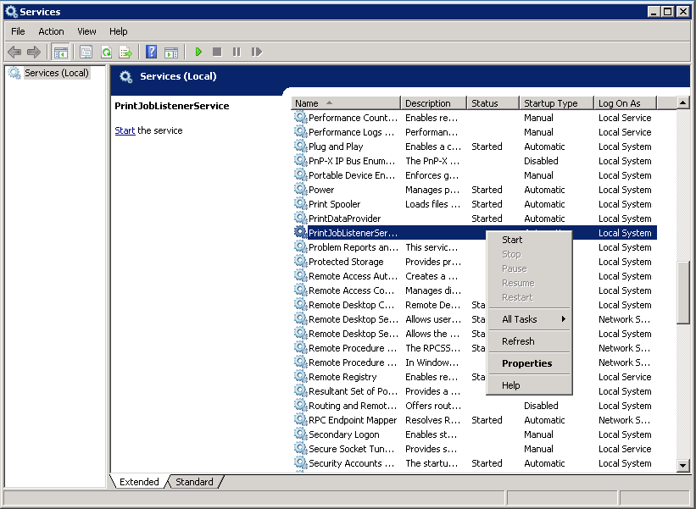

Figure 21: Restarting PrintJobListnerService

***Note:***

Only on restarting “PrintJobListnerService”, **the new port configuration will be applicable**.